XC-588L
Blood Bank Refrigerators

Operation Manual

Thank you for buying a Meiling Blood bank refrigerator!

For your personal safety and better performance of this unit, please read this Operation Manual thoroughly and save it properly for future reference.
Failure to read, understand and follow the instructions in this manual may result in damage to the unit, injury to operating personnel and poor equipment performance.
The material in this manual is for information purposes only. The contents and the product it describes are subject to change without notice. Zhongke Meiling Cryogenic Co.,LTD makes no representations or warranties with respect to this manual.

Always use the proper protective equipment(clothing, gloves, goggles etc.).
Always follow good hygiene practices.
Each individual is responsible for his or her own safety.
 Safe Notice
- Please read this manual carefully when use our machine at the first time.
- The one who operate Ultra Low temperature Freezer should be trained and authorized
- The maintenance of equipment should be made by Zhongke Meiling or their’s agent
- If happen the questions which not mentioned in the manual,please contact Zhongke Meiling or agent ,and ask the right way to slove.
- The better to use the Zhongke Meiling fittings,If the customers use other’s spare parts,Zhongke Meiling will be not responsible for the bad effect.But the customers can apply for Zhongke Meiling
- Should be check-up and maintenance to Ultra low temperature freezer at the stated time.
- Ultra Low temperature Freezer prohibit to storing alive life,flowers and others which not be fit for the low temperature.
- Ultra Low temperature Freezer through condensator to reach refrigeration.To ensure the freezer run regularly and venlation, The body back and both sidesaway from the wall at least 30cm.,and not be blocked by barrier.
- When Ultra Low temperature Freezer working,The inner temperature is very low.So if not wear glove,Please don’t touch the cover board.
- If the power shut off，Please wait 5minutes.Can to connect again,to prevent the compressor damage.
1
Schematic Picture and Description
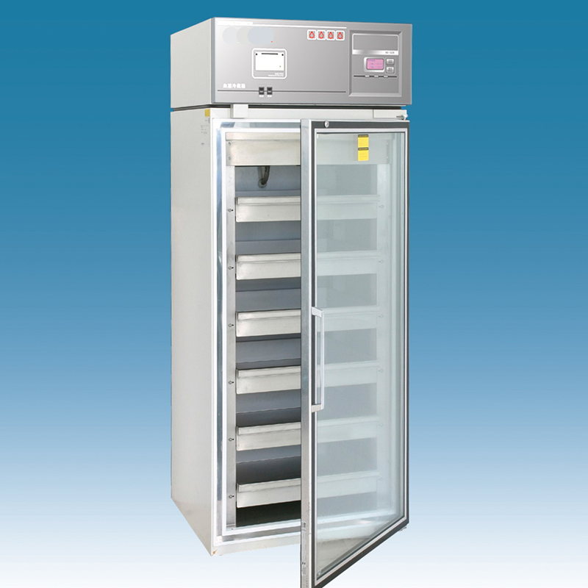
Heat button
Door
Doorknob

Control Panel

Door Switch

Temperature printer

Cabinet
Lamp Switch

Notice：the heat button here is to warm the door body when there is water congealed on the inside of the glass door . ( left black button)
The right black button is the switch of the inside lamp.
Because the freezer amelioration and the model different,The actual product may not the same as the photo,Please follow the actual freezer.
Series of Ultra-low temperature freezer is designed to store materials under very low temperature condition for hospital, epidemic station, blood bank, research institute, university, biological pharmaceutical industry and gene engineering, etc. The internal temperature in cabinet can be easily adjusted through the keys in control panel. All operations are convenient and reliable.

2
Pre-Installation
- How to transport：Pick up the unit from the bottom of tank and a slant plane within 45° is acceptable. All transportation should be carefully.
- Remove all wrappers.
- Check accessories and documents according to package list.
- Clean the unit thoroughly before any operation.
- Installing location：Do not position the unit in direct sunlight or near heating diffusers, radiators, or other sources of heat. The ambient temperature should not exceed 32℃. A minimum 20cm space on the sides, rear and top should be provided for better air circulation and heat discharge. Location where is too cold and place with high humidity or can be easily splashed by water are forbidden.

The freezer working condition:
The environment temperature：10℃～30℃
The relative humidity：≤80%

No strong shake and causticity gas around.
No sunshine and other cold/hot power effect.

Safety Introduction
- Power supply：This ULT freezer is designed operating under 220V/50HZ AC power supply. The unit can normally start under the voltage varying from 198V to 242V.
- Must provide one single exclusive plug receptacle with credible grounding to unit.Don’t lengthen the line randomly. If you need,Please use 2.5mm2 copper line,you should keep 4mm2 line to connect the electrical outlet.
- Inflammable and explosive materials, as well as high corrosive acid and alkali must be strictly prohibited in cabinet.
- Keep the key properly avoiding the children take it to open the back door which may result in unexpected injury.
- For liquid temperature measurement, the bottles are filled with a 250 ml solution of 10 parts water and 1 part glycerol. The probes must extend at least 80mm into the solution and the bottle cap must fit tightly to minimize evaporation.
- Keep the lamp off in use for saving energy sources and stabilization temperature in cabinet.

3
Operation Direction
（1）Function Introduction for Display Panel
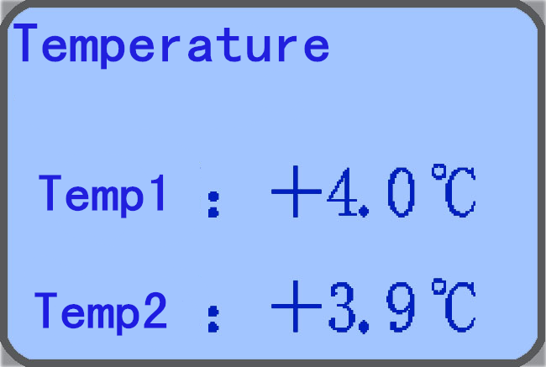
Print

Inspect/ Mute
▲
▼
set

⁰C LCD code display window. The window displays the real-time internal temperature of freezer with unit ℃ under
＋4.0℃
＋3.9℃

normal running condition, and displays different hint string under set condition: （Refer follows for details）

- “Print”：This unit develops a function of automatically print the real-time temperature data and manually print the latest seven days’ data；
- “Inspect/ Mute”：Press this key to stop alarm buzzing. Press this key to check time, the number of door opening and alarm memory;
- “▼”“▲”：Function adjustment pads. Press these pads to realize different functions combining with different function keys；
- “Setting”： Press this key to set the function adjustment parameter;

（2） Initial Start-up
- Connect the power supply and switch the on-off on the back of freezer working status；
- “Mute”：Press the “Mute”, the alarm buzzer switches to alarm-off status. Now, the alarm buzzer will be closed under any error condition.
- Set temperature: The default temperature is set as 4℃ in factory. Please don’t set any other temperature value.
  - “LTL”： When the actual temperature in tank is lower than the low temperature limit (LTL) setting, the window displays redness and system alarms to attract user’s notice；
  - “HTL”：When the real temperature in tank is higher than the high temperature limit (HTL) setting, the window displays redness and system alarms to attract user’s notice. (During the initial start-up, a “HTL” alarm is normal operation. After the temperature is stabilized and the “HTL” alarm stops you can put goods in your freezer);
- “Ajar” indicator：The window displays redness and system alarms to attract if the door opens for more than 1 miniature. After the door is closed, the alarm stops；
- upper Probe: show the upper cabinet temperature.
- Lower probe: show the lower cabinet temperature.
※7. When the rechargeable battery existences, when the power source supply disruption, the screen still lightened, showed the real-time cabinet temperature, recorded the number of door opening, LTL and HTL alarm. But the ventilator, the lamp and the refrigeration system does not work. (If the freezer has not been used for long time, the battery does not have electric quantity, it is normal that the window have no display. When freezer power source puts through, electrification completes automatically.)

please close the power switch on the back of the box when the power cut for a long time( longer than three hours), otherwise the electric quantity loses and affects the battery service life!

（3）Functions Setting

- time set:
Press " inspect" key, The Digital-Code window displays Year, month, date, hour, minute. Now set the current clock. Temperature window displays current temperature and the Ten bit of year blinks in clock display window. Press “▼” to change the blinking bit which changes in sequence according “Ten bit of year→One bit of year→Ten bit of month →One bit of month→Ten bit of day→One bit of day→Ten bit of hour→One bit of hour→ Ten bit of min.→One bit of min.→Am or PM→ Ten bit of year”. All these shows in the format as: “Y；D；AM；PM”. Now press “▲”to add 1 per touch to the blinking bit which will return to the min. after the max. When the set finishes, press “Enter” to activate the setting. Then the number in time display window stops blinking and the set mark “TIME” disappears to exit the time setting status. If no keys are pressed within 15 seconds the system exits the set status without any data saved and reverts to its normal display.
- Press " inspect " key two time display the time of the door opening/closing, twenty opening/closing occurrences are stored in the monitor’s memory and may be reviewed at any time by the operator. Pressed "▲" and "▼" key choose the occurrences .
- Press " inspect " key three time display the time of alarm occurrences, twenty alarm occurrences are stored in the monitor’s memory and may be reviewed at any time by the operator. Pressed "▲" and "▼" key choose the occurrences .
- Auto print：
Press the “Print” key, the system switches to auto print mode. Now AUTO displays in the LCD window and the print indictor lamp changes into normally bright. Under this mode press the print key of printer to automatically print recorded data. All data are printed per 20 miniatures with a format as “Year, Month, Day, Time, Temperature”. When the print finishes, the buzzer buzzes for 5 seconds, then the system exits the print mode. To cancel print midway, press “Print” again.
- Manual print：
Press “Print” twice within 3 seconds, the system switches to manual print mode. Now the display window shows “----1” and the print indicator lights. Then press the print key of printer to print the current recorded data. Press “▲” once to print the data of previous day and the display window shows “----2”. Similarly, the recorded data of others days can be printed manually. All data are printed at an interval of 20 miniatures in a format as “Year, Moth, Day, Time, Temperature”. When the print completes, the buzzer buzzes for 5 seconds, then the system exits the print mode. To cancel print midway, press “Print” again.
。
Special Notice：
- Functions marked with “*” are available only for some users or when the unit is equipped with the optional parts.
- DO NOT place anything immediately after the power supply is connected. About a 6~8 hours’ no-load running before storing materials is recommended.

4
Defrost ●Unused ● Maintenance
- Leave Unused：If the unit is not used for long time, please disconnect power supply and maintain as the following procedures. For next time operation, ensure there is not any water around the liners to avoid the seal of door is frozen.
- Note：Any electric heater, metal tool or edge tool CAN NOT be used during defrost operation.
Note：DO NOT sprinkle water on the faces of cabinets, which may decrease insulating property of electric parts and rust metal parts.
DO NOT use hot water, corrosive cleanser and organic solvent!

5
Service after sale
Some unexpected failures may arise during running. Please pay attention to the running status of your ULT freezer. If any exceptional case arises, please check and solve it according to the following introductions. If the problem is not solved well, please contact our service center for details.

Problem | Possible Cause
ULT freezer does not operate | - Power outage has occurred.  - The plug is bad or not securely plugged-in.  - Fuse is blown.  - Voltage is too low or too high.
Compressor does not work | - Power in control panel is off.  - Temperature setting is wrong.
Temperature is higher than setting | - Frost in inner wall is too thick内壁是否结霜太厚？  - The door is not closed properly or is opened too frequently.  - Overfull materials are put into chamber.  - Ambient temperature is too high.
Too great noise | - Freezer is not leveled well.  - Freezer leans upon the wall.
Below are normal operation：
- There are some light clashes when the compressor starts up and stops.
- During rainy and watery season some frost may accumulate on the surfaces of cabinets. Please clean it with dry rag.
- DO NOT open the door twice within 5 miniatures. This may lead the hot air into the interior of freezer and the door may be difficult to open because of a negative pressure due to a sharp decrease of temperature of this part air.

- If the freezer have liquid flowing sound,the reason is the refrigerant flowing in the pipeline.

Notice: Before call the service engineer,Please clean and disinfect the freezer.
Condition:Can not shake heavily, strike,prevent drench.
Environment Temperature: -40℃～+55℃, Relative humidity: 10％～90％.

6
Specifications

Model | XC-358L | Safety Type | I Class B type
Climate Type | N | Input Power（W） | 700
Internal Temp. | 4(±1)℃ | Refrigerant | R134a
Valid Capacity（L） | 588 | Exterior Dimensions （L×W×H）（mm） | 860x760x1977
Rated Voltage（V～） | 230 | Rated Power（Hz） | 50

Package List：

Name | Operation Manual | Key | Plastic Bag
Amount | 1 | 2 | 1

7
Circuit Diagram
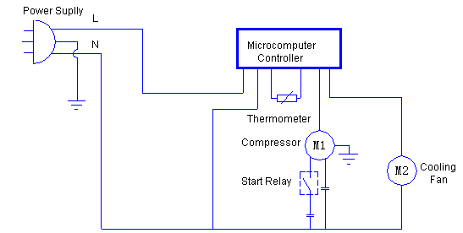

All technical parameters and circuit diagram in nameplate are final ones for your units.

After sale service line:86 551 64317378

